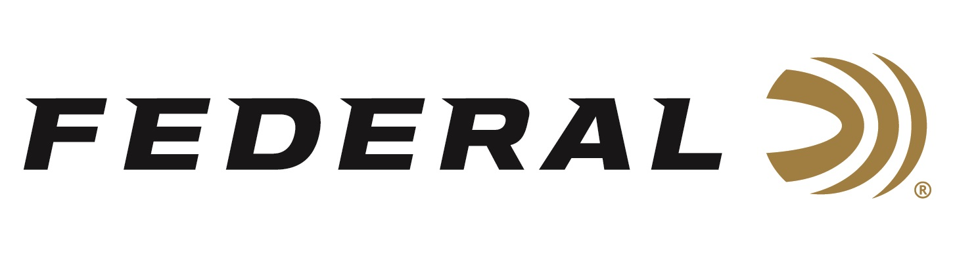

FOR IMMEDIATE RELEASE

Federal Ammunition Introduces New Prairie Storm 16- and 28-Gauge Upland Hunting Loads

ANOKA, Minnesota – November 11, 2020 – New 16- and 28-gauge Federal Premium Prairie Storm FLITESTOPPER (FS) Lead loads use the updated FLITECONTROL FLEX wad and a mixed payload of standard pellets with FS lead to produce full, consistent patterns from these smaller payloads. The improved wad design can be used through both ported and standard chokes for better patterning and versatility. Shipments of this product have begun to arrive at dealers.

“Our all-new 28- and 16-gauge offerings use the full-length FLITECONTROL FLEX wad, which was introduced with the launch of Federal Premium’s redesigned Black Cloud waterfowl shotshells and HEAVYWEIGHT TSS turkey loads. The wad’s unique design improves pattern density and consistency when fired through ported and non-ported chokes,” said Dan Compton, Federal Shotshell Product Manager. “FLITESTOPPER pellets feature a raised cutting ridge encircling the exterior gives the pellets an unparalleled ability to slice through feathers and flesh, with no loss of penetration or adverse effect on ballistics and flight characteristics. This cutting action creates significantly larger wound channels.”

These enhanced design elements deliver holes in the bird, not the pattern. Testing done at the Federal Factory in Anoka, MN shows a No. 4 load puts more than 75 percent of its pattern in a 30-inch circle at 40 yards with a modified choke.

Features
- New options for sub-gauge shotguns, specifically 16- and 28-gauge
- FLITECONTROL FLEX wad can be used through all upland chokes
- Payload mix of 70 percent standard copper-plated lead and 30 percent FS Lead
- FS lead produces even edge-to-edge patterns and creates large wound channels
- Time-tested, ultra-effective powder and a reliable primer.
- Supports Pheasants Forever through on-box royalty program

Part No. / Description / MSRP
PFX164FS 4 / PS 16-gauge 2 ¾-inch 1 1/8-ounce No. 4, 1,425 fps, 25-count / $35.99
PFX164FS 5 / PS 16-gauge 2 ¾-inch 1 1/8-ounce No. 5, 1,425 fps, 25-count / $35.99
PFX164FS 6 / PS 16-gauge 2 ¾-inch 1 1/8-ounce No. 6, 1,425 fps, 25-count / $35.99
PFX289FS 6 / PS 28-gauge 2 ¾-inch 13/16-ounce No. 6, 1,300 fps, 25-count / $34.99
Federal has supported Pheasants Forever since 1998. That on-going support includes an on-box ammunition royalty program. For every box of Prairie Storm purchased, which sports the Pheasants Forever or Quail Forever logo, Federal donates a portion of the proceeds to the organization’s habitat and education programs. So far, Federal has sold more than 55 million of these special shotshells to support these important organizations.

Federal ammunition can be found at dealers nationwide or purchased online direct from Federal. For more information on all products from Federal or to shop online, visit www.federalpremium.com.

Press Release Contact: JJ Reich
Senior Manager – Press Relations
E-mail: VistaPressroom@VistaOutdoor.com

About Federal Ammunition
Federal, headquartered in Anoka, MN, is a brand of Vista Outdoor Inc., an outdoor sports and recreation company. From humble beginnings nestled among the lakes and woods of Minnesota, Federal Ammunition has evolved into one of the world's largest producers of sporting ammunition. Beginning in 1922, founding president, Charles L. Horn, paved the way for our success. Today, Federal carries on Horn's vision for quality products and service with the next generation of outdoorsmen and women. We maintain our position as experts in the science of ammunition production. Every day we manufacture products to enhance our customers' shooting experience while partnering with the conservation organizations that protect and support our outdoor heritage. We offer thousands of options in our Federal Premium and Federal® lines-it's what makes us the most complete ammunition company in the business and provides our customers with a choice no matter their pursuit.

